SECTION -A
- Why Petrol evaporates more rapidly than water at ordinary temperature?
- Differentiate between centre of pressure and centre of buoyancy.
- Differentiate between tangential and normal acceleration of fluid particle.
- Define momentum correction factor.
- Differentiate between free and forced vortex flow.
- What do you understand by stagnation pressure and dynamic pressure.
- Define Mach number and its significance.
- Which among Venturi-meter, orifice-meter and rota-meter is the most accurate and write down coefficient of discharge for each one.
- What is hydrostatic paradox.
- What is the difference between a notch and a weir.
- Differentiate between specific weight and specific gravity of an oil.
- Define centre of pressure of a surface.
- Differentiate between rotational and irrotational flow.
- Write some practical applications of Bernoulli's equation.
- Define the term coefficient of contraction.
- What is a convergent-divergent mouthpiece?
- Explain the term dimensional analysis?
- Discuss important characteristics of laminar flow.
- How are turbulence classified/
- What is free jet of liquid?
- Distinguish between compressible and incompressible fluids.
- Define mass density and specific weight.
- What is meant by intensity of pressure?
- Differentiate between Newtonian and Non-newtonian fluids.
- Define path line and streak line.
- What is the difference between pitot tube and pitot static tube?
- Explain the term" dimensional homogeneous equations".
- What are Manometers?
- Define and explain Metacentre.
- Distinguish between solids & gasses.
- Derive the hydrostatic Law of pressure distribution.
- Define convective and local acceleration.
- Distinguish between free and forced vertex motion.
- Define and derive Reynold's Number.
- Explain the phenomena of Buoyancy.
- In laminar flow through circular the velocity distribution is ...........
- Differentiate between hydraulic gradient line and total energy line.
- Differentiate between laminar & turbulent flow.
- The viscosity of liquid............ with increase in temperature.
- Define compressibility.
- Explain total pressure on a surface.
- Differentiate between steady and unsteady flow.
- State the limitations of Bernoulli's equation.
- Define the co-efficient of discharge.
- What is a convergent-divergent mouth piece?
- Define the term dimensional homogeneity.
- What do you understand by Reynolds No.?
- Define moment of a momentum equation?
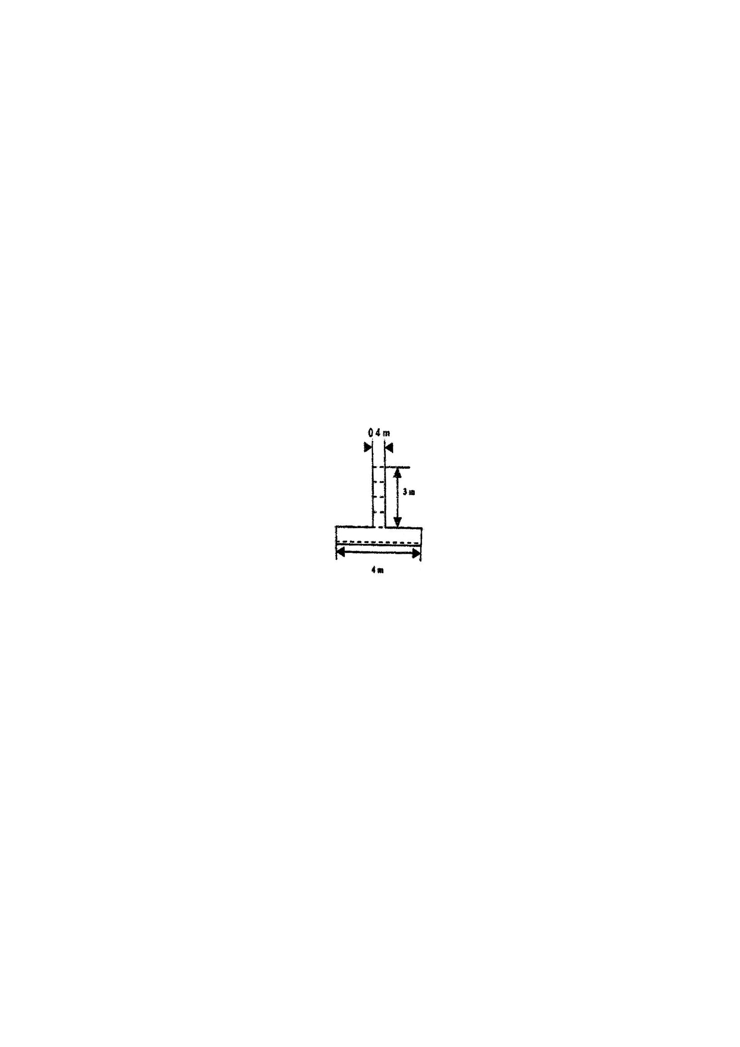
- Define hydraulic gradient line.
- Differentiate between ideal and real fluids
- Define surface tension and capillarity.
- What is Pressure Head?
- State Pascal's Law.
- Differentiate between rotational and irrotational flow.
- What is a venturimeter? Where do we use it?
- Define the terms dimensional analysis and model analysis?
- How are manometers classified?
- Define and explain in brief Metacentric height.
- What is a Rotameter?
SECTION -B
- Fig. shows a tank full of water, find:
(a) Total Pressure at bottom of tank.
(b) Weight of water in the tank.
(c) Hydrostatic paradox between results
of (a) and (b) width of tank=2m.
- What are the conditions of equilibrium for floating and submerged bodies.
- A cylindrical container with height 60 cm and radius 10 cm is filled with water upto a depth of 40 cm. the container is sealed both at the top and bottom and is rotated about its vertical axis at 360rpm. Calculate the height of paraboloid formed. What should be the rotational speed if the parabola is to just touch the centre bottom of vessel?
- In a steady flow, the velocity components are :
u= 2kx, v=2ky, w= - 4kz.
Find the equation of a streamline passing through the point (1,0,1)
- Write the impulse momentum equation and the moment of momentum equation ? What is the difference between them in terms of variable to be found?
- Prove that the centre of pressure of a completely submerged plane surface is always below the centre of gravity of the submerged surface or at most coincide with the centre of gravity when the plane surface is horizontal.
- Describe the use and limitations of flow net.
- Derive Euler's equation of motion along a stream line.
- Explain fundamental quantities, derived quantities and repeating variable.
- What do you understand by turbulent flow?
- What factors decides the type of flow in pipes?
- Define the following
(i) Real & ideal fluid
(ii) Stream function & velocity potential function.
- Derive the continuity equation for 3 Dimensional flow differential form.
- Derive Darcy's weirs Bach equation for loss of heat due to friction in a circular pipe.
- Explain with neat sketch the working of a rotameter.
- State and derive impulse momentum equation.
- How will you determine the metacentric height of a floating body experimentally? Explain with neat sketch.
- Define path line, streak line and the stream line. For what type of flow these lines are identical? Discuss.
- Discuss the relative merits and demerits of venturimeter with respect to orifice meter.
- Explain the significance of dimensional analysis as applied to fluid flow problem.
- State and prove Bernoulli's Theorem.
- State and explain the Newton's law of viscosity.
- Differentiate between manometer and mechanical gauges. What are different types of mechanical pressure gauge?
- What is meant by intensity of pressure? How does it vary with the depth of fluid?
- Explain and calculate the metacentric height of a floating body theoretically.
- Explain the term dimensional homogeneity. Also enumerate the applications of dimensional homogeneity.

SECTION -C
- In a vertical pipe conveying oil of sp. Gravity 0.8, two pressure gauges have been installed at A & B, where the diameters are 16cm and 8 cm respectively. A is 2m above B. The pressure gauge readings have shown that pressure at B is greater than at A by 0.1 bar. Neglecting al losses, calculate the flow rate. If gauges at A and B are replaced by tubes filled with same liquid and connected to U-tube manometer containing mercury, calculate the difference of level of mercury in two limbs of manometer.
- (a) What do you understand by major and minor energy losses in pipes? Derive an expression for loss of heat due to obstruction in the pipe.
(b) What is an equivalent pipe, derive an expression for equivalent size of this pipe.
- (a) With Froude number as the criterion of dynamic similarity for a certain flow situation, work out the scale factors for velocity, time discharge, acceleration, force, work and power in terms of the scale factor for length.
(b) In the model test of a spill way, the discharge and velocity of flow over the model were 2m³/s and 1.5m/s respectively. Calculate the discharge and velocity over the prototype which is 36 times the model size.
- Derive continuity equation in cylindrical co-ordinates.
- Show that the momentum correction factor for laminar flow through a circular pipe is 4/3.
- Write short notes on the following:
(a) Dimensionless numbers and their significance.
(b) Notches and weirs.
- Derive continuity equation in Cartesian co-ordinates.
- A 30 cm diameter horizontal pipe terminates in a nozzle with the exit diameter of 7.5 cm. If the water flows through the pipe at a rate of 0.15 m³/s what force will be exerted by the fluid on the nozzle.
- Write short notes on:
(a) 'Hydrostatic paradox.
(b) Flow nets.
- (a) State the Buckingham's II theorem and give the steps involved in this method.
(b) In a line 20 model of stilling basics . The height of hydraulic tump is the model is observed to be 20 m. What is the height of hydraulic tump is proto type. If the energy dissipated in the modes is 1/10 KWL What is the corresponding value in proto type.
- (a) Write notes on
(i) Pilot tube
(ii) Orificemeter
(b) The Head of water over a rectangular notch is 90 cm and discharge is 300 Lt/sec. length of the notch if Cd= 0.62.
- (a) List the various losses in Pipe Flow.
(b)Anopen Circular Cylinder of 15 cm diameter & 100 cm long contains water up to a height of 80 cm. Find the maximum speed at which the cylinder is to be rotated about its vertical axis so that no water spills.
- Describe the Buckingham's' method to formulate a dimensionally homogeneous equation between the various physical quantities effecting a certain phenomenon.
- Show that the energy correction factor for laminar flow through a circular pipe is 2.
- Write short notes on:
(a) Pitot tube.
(b) Darcy equation.
- What is Euler's Equation of motion? How will you obtain Bernoulli's equation form it?
- Check whether the following functions satisfy continuity and are valid potential functions, A is numerical constant:
(a) $φ=\frac{A}{2}\left(x^{2}−y^{2}\right)$
(b) $φ=A\left(\text{cos}x+\text{sin}y\right)$
(c) $φ=a{\text{log}}_{e}\text{xy}$
- Write notes on the following:
  - Rayleigh's method for dimensional analysis.
  - Kinetic energy and momentum correction factor.

