# SI ENGINE MANAGEMENT

1. Define open loop control for fuel ignition system.
2. List the SI engine fuel system components.
3. Write the differences between throttle body injection and MPFI system.
4. Plot conversion efficiency versus lambda of a 3 way catalytic converter.
5. List the various types of Bosch injection systems.
6. What is meant by Group injection technique?
7. List the various fuel system components.
8. List the various phases of electronic engine control.
9. Explain briefly about Fuel control maps.
10. List the advantages of Electronic ignition systems.
11. What do you meant by engine knock?
12. What is the need for cold start and warm up phases in fuel injection system?
13. What is ignition advance?
14. Why the ignition advance required in S I Engines?
15. What is knocking in S I Engine? What is the system we have for controlling the knock?

# CI ENGINE MANAGEMENT

1. What is meant by Electronically controlled Unit Injection system?
2. What is meant by Pilot injection?
3. What do you understand by post injection.
4. Why Exhaust Gas Recirculation is necessary for an engine.
5. List Fuel injection system parameters affecting combustion
6. What are the emissions in CI engines?
7. What is meant by advanced post injection and retarded post injection?
8. List the components of the common rail fuel injection system.
9. What are the parts used in the C R D I?
10. Explain the Term E G R?
11. What is Rail Pressure Limiter?
12. What are the advantages of C I Engine management system?
13. What is a flow limiter and how it controls the flow?

# VEHICLE MANAGEMENT SYSTEMS

1. Explain ABS system, its need, layout and working.
2. Explain Electronic control of suspension – Damping control.
3. a) Explain the working of Electric power steering,

b) Explain working of air bag system

1. Explain cruise control system.
2. Explain vehicle tracking system.
3. Explain On board diagnostics (OBD I & II).
4. Explain Collision avoidance Radar warning system.

# SENSORS

1. Give a list of the various types of sensors used in the MPFI petrol engine.
2. What is lambda sensor? Write use of it in vehicles.
3. Define magnetostriction phenomenon.
4. List 4 variables sensed in engine control system.
5. Explain briefly the Hall Effect.
6. Explain briefly the principle of thermistor
7. Explain the piezo electric effect.
8. What is the need to know the throttle position?
9. How air mass flow is calculated?
10. Why crank shaft position and cam position is to be known?
11. Explain briefly about tire pressure sensor.
12. What is closed loop control using EGO sensor?
13. What is the necessity for measuring the crank, cam shaft positions and engine speed in S I engine management system?
14. What is the need for measuring steering torque and steering position?
15. How the tyre pressure and brake pressure are measure in automobiles control systems?
16. What is the necessity for measuring the crank, cam shaft positions and engine speed in S I engine management system?
17. What is the need for measuring steering torque and steering position?
18. How the tyre pressure and brake pressure are measure in automobiles control systems?

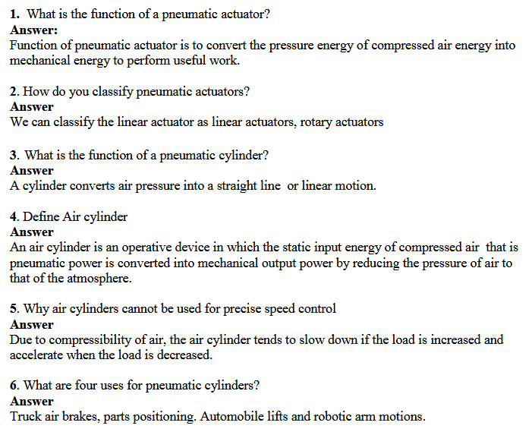

**1. Which type of motion is transmitted by hydraulic actuators?**  
a. linear motion  
b. rotary motion  
c. both a and b  
d. none of the above  
**ANSWER: c. both a and b**

**2. What is the function of electric actuator?**  
a. converts electrical energy into mechanical torque  
b. converts mechanical torque into electrical energy  
c. converts mechanical energy into mechanical torque  
d. none of the above

**ANSWER: a. converts electrical energy into mechanical torque**

**3. Which of the following is a hydraulic cylinder based on construction?**  
a. single acting cylinder  
b. double acting cylinder  
c. welded design cylinder  
d. all the above  
**ANSWER: c. welded design cylinder**

**4. Which energy is converted into mechanical energy by the hydraulic cylinders?**  
a. hydrostatic energy  
b. hydrodynamic energy  
c. electrical energy   
d. none of the above  
**ANSWER: a. hydrostatic energy**

**5. What is the advantage of using a single acting cylinder?**   
a. high cost and reliable  
b. honing inside the inner surface of pump is not required  
c. piston seals are not required  
d. all the above  
**ANSWER: c. piston seals are not required**  
**6. Why are hydraulic cylinders cushioned?**  
a. cushioning decelerates the piston of a cylinder  
b. stress and vibrations can be reduced  
c. both a and b  
d. none of the above   
**ANSWER: c. both a and b**

**7. Which of the following statements is true?**  
a. Tie-rod cylinders are used in applications having working pressure of 70 bar   
b. Welded type cylinders are used in systems having working pressure more than 70 bar   
c. Tie-rod cylinders can be used in systems having working pressure more than 70 bar   
d. All the above  
**ANSWER: d. All the above**

**8. Which of these actions does a hydraulic cylinder perform?**  
a. pushing  
b. lifting  
c. both a and b  
d. none of the above

**ANSWER: c. both a and b**

**9. Leakage in welded type of hydraulic cylinder is prevented by**   
a. wiper in gland cover  
b. rod seal in end cover  
c. rod seal in gland cover  
d. both b and c  
**ANSWER: c. rod seal in gland cover**

**10. In single acting hydraulic cylinders, the piston comes back to its original position due to**  
a. spring force  
b. self-weight  
c. momentum of a flywheel  
d. all the above  
**ANSWER: d. all the above**

**This set of Instrumentation Transducers Multiple Choice Questions & Answers (MCQs) focuses on “Sensor Systems”.**

1. Which of the following is correct for tactile sensors?  
a) Touch sensitive  
b) Pressure sensitive  
c) Input voltage sensitive  
d) Humidity sensitive  
View Answer

Answer: a  
Explanation: Tactile sensors are those which sensitive to touch.

2. Change in output of sensor with change in input is ____________  
a) Threashold  
b) Slew rate  
c) Sensitivity  
d) None of the mentioned  
View Answer

Answer: c  
Explanation: Sensitivity of a sensor is the change in output for a change in input.

3. Which of the following can be cause for non-zero output when zero input?  
a) Bias  
b) Slew  
c) Offset  
d) Offset or bias  
View Answer

Answer: d  
Explanation: For ideal condition, zero input produces zero output.

4. Sensitivity of a sensor can be depicted by _______________  
a) Niquist plot  
b) Pole- zero plot  
c) Bode plot  
d) None of the mentioned  
View Answer

Answer: c  
Explanation: Bode plot can be used for describing the sensitivity of a sensor.

5. Which of the following error is caused by a reversal of measured property?  
a) Hysterisis  
b) Noise  
c) Digitization error  
d) Quantization error  
View Answer

Answer: a  
Explanation: Digitization error is caused by a reversal of measured value.

6. Smallest change which a sensor can detect is ____________  
a) Resolution  
b) Accuracy  
c) Precision  
d) Scale  
View Answer

Answer: a  
Explanation: Resolution is the smallest change a sensor can detect.

7. Thermocouple generate output voltage according to ____________  
a) Circuit parameters  
b) Humidity  
c) Temperature  
d) Voltage  
View Answer

Answer: c  
Explanation: Thermocouple is a device which is capable of producing output voltage according to input temperature.

8. Sensor is a type of transducer.  
a) True  
b) False  
View Answer

Answer: a  
Explanation: Sensor is a device which enables measurement of input value.

9. Which of the following is not an analog sensor?  
a) Potentiometer  
b) Force-sensing resistors  
c) Accelerometers  
d) None of the mentioned  
View Answer

Answer: d  
Explanation: All of the mentioned devices are analog sensors.

10. Measured property have no relation with error.  
a) True  
b) False  
View Answer

Answer: a  
Explanation: Error of a system is independent of the measured value.

**What is primary transducer?**

Bourdon tube acting as a primary transducer senses the pressure and converts the pressure into displacement.

No output is given to the input of the [bourdon tube](https://instrumentationtools.com/c-bourdon-tube-theory/). So it is called primary transducer. Mechanical device can act as a primary transducer.

**What is secondary transducer?**

The output of the Bourdon tube is given to the input of the [LVDT](https://instrumentationtools.com/lvdt-working-principle-animation/).

There are two stages of transduction, firstly the pressure is converted into a displacement by the Bourdon tube then the displacement is converted into analog voltage by LVDT. Here LVDT is called secondary transducer. Electrical device can act as a secondary transducer.

**What is passive transducer?**

In the absence of external power, transducer cannot work and it is called a passive transducer.

Example: capacitive, inductive, resistance transducers.

**What is active transducer?**

In the absence of external power, transducer can work and it is called active transducer.

**Example:**

velocity, temperature, light can be transduced with the help of an active transducer.

**What is analog transducer?**

These transducers convert the input quantity into an analog output which is a continuous function of time.

Thus a strain gauge, an LVDT, a thermocouple or a thermistors may be called analog transducer, as they give an output which is a continuous function of time.