Q 1.Why is fluid power preferred in mobile vehicles?
a) power can be transmitted without any delay | b) when overloaded, fluid power systems stop without damaging the components
c) speed variation cannot be achieved | d) fluid is non-compressible
Correct answer: a,b and d

Q 2. Pressure of 1 bar is equal to
a) 14.5 psi | b) 145 psi
c) 12.5 psi | d) 145 x 10₋₆ psi
Correct answer: 14.5 psi
Q 3. What effect does overloading have on fluid power and electrical systems?
a) electrical components get damaged in electrical systems | b) fluid power system stops working without damaging the components
c) both a. and b | d) none of the above
Correct answer: c. both a. and b.
Q 4. How is power transmitted in fluid power systems?
a) power is transmitted instantaneously | b) power is transmitted gradually
c) both a. and b. | d) none of the above
Correct answer: power is transmitted instantaneously
Q 5. Which of the following statements is/are false?
a) air is non-compressible | b) less power is developed in fluid power systems than conventional systems
c) mechanical linkages used for load handling purposes have high efficiency | d) all the above
Correct answer: d. all the above
Q 6. Fluid Power circuits use schematic drawings to
a) simplify component function details | b) make it so that only trained persons can understand the fuctions
c)make the drawing look impressive | d) none of the above
Correct answer: 1
Q 7. In which systems, spool of the servo valve is operated by a torque motor?
a) hydromechanical servo systems | b) electrohydraulic servo systems
c) conventional servo valve | d) all the above
Correct answer: electrohydraulic servo systems
Q 8. Which of the following systems generate more energy when used in industrial applications?
a) hydraulic systems | b) pneumatic systems
c) both systems generate same energy | d) cannot say
Correct answer: a. hydraulic systems
Q 9. Which type of compressor requires a reservoir for compressed air and why?
a) rotary compressor to avoid pulsating effect | b) reciprocating compressor to avoid pulsating effect
c) both rotary and reciprocating compressors to avoid pulsating effect | d) none of the above
Correct answer: reciprocating compressor to avoid pulsating effect
Q 10. Which of the following factors is considered while selecting a compressor?
a) type of oil filter required | b) volumetric efficiency
c) viscosity of the liquids used | d) all the above
Correct answer: b. volumetric efficiency
Q 11. Which of the following is a component used in air generation system?
a) pressure switch | b) pressure gauge
c) drier | d) intercooler
Correct answer: c. drier
Q 12. Where is an intercooler connected in a two stage compressor?
a) intercooler is connected after the two stage compressor | b) intercooler is connected between the two stages of the compressor
c) . intercooler is connected before the two stage compressor | d) none of the above
Correct answer: b. intercooler is connected between the two stages of the compressor
Q 13. Select the correct order of process occurring in pneumatic system
a) Air preparation – air generation – air control – air consumption | b) Air preparation – air control– air generation– air consumption
c) Air generation - air preparation – air control – air consumption | d) none of the above
Correct answer: Option: c.
Q 14. What is difference between regulator and pressure switch?
a) regulator operates at set value pressure while pressure switch operates with slight fluctuation in pressure | b) . pressure switch operates at set value pressure while regulator operates with slight fluctuation in pressure
c) regulator and pressure switch are same | d) none of the above
Correct answer: a. regulator operates at set value pressure while pressure switch operates with slight fluctuation in pressure
Q 15. Select the correct standard symbols for the hydraulic check valve
a) 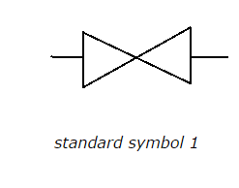 | b) 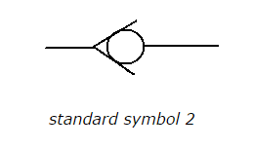
c) 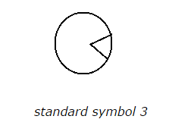 | d) 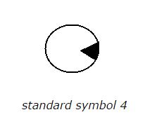
Correct answer: b
Q 16. Select the correct standard symbols for the hydraulic motor
a) | b)
c) | d)
Correct answer: d
Q 17. Select the correct standard symbols for the pneumatic motor
a) | b)
c) | d)
Correct answer: c
Q 18. Select the correct standard symbols for the shut-off valve
a) | b)
c) | d)
Correct answer: a
Q 19. Mass of water vapour in unit volume of air is known as
a) relative humidity | b) absolute humidity
c) saturation quantity | d) none of the above
Correct answer: b. absolute humidity
Q 20. Which valve is also known as memory valve?
a) single pilot signal valve | b) double pilot signal valve
c) roller lever valve | d) logic valve
Correct answer: double pilot signal valve
Q 21. Which of the following logic valve is known as shuttle valve?
a) OR gate | b) AND gate
c) NOR gate | d) NAND
Correct answer: a. OR gate
Q 22. In pneumatic systems, AND gate is also known as
a) check valve | b) shuttle valve
c) dual pressure valve | d) none of the above
Correct answer: c. dual pressure valve
Q 23. What is a pressure sequence valve?
a) . it is a combination of adjustable pressure relief valve and directional control valve | b) it is a combination of nonadjustable pressure relief valve and directional control valve
c) . it is a combination of adjustable pressure reducing valve and check valve | d) it is a combination of adjustable pressure reducing valve and flow control valve
Correct answer: a. it is a combination of adjustable pressure relief valve and directional control valve
Q 24. Which of the following is used to sense the initial and final positions of a piston rod?
a) lever operated direction control valve | b) limit switch
c) roller lever valve | d) all the above
Correct answer: d. all the above
Q 25. Which valve gets activated only in one direction that is forward or backward movement of the piston rod?
a) roller lever valve | b) idle roller lever valve
c) both a and b | d) none of the above
Correct answer: b. idle roller lever valve
Q 26. Which numbers are used to denote retraction of a piston rod?
a) even numbers | b) odd numbers
c) both even and odd numbers | d) none of the above
Correct answer: b. odd numbers
Q 27. Which of the following is an element of time delay valve?
a) flow control valve | b) direction control valve
c) both a and b | d) none of the above
Correct answer: c. both a and b
Q 28. Which of the following is the correct displacement diagram for a single acting cylinder, where 0 and 1 on the left hand side are initial and final positions of piston rod respectively and a, b, c are stages of extension and retraction?
a) 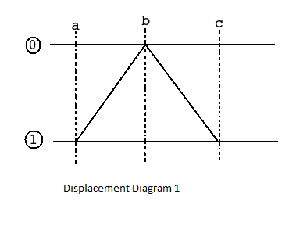 | b) 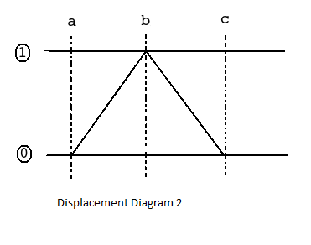
c) 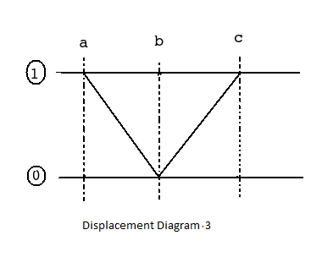 | d) 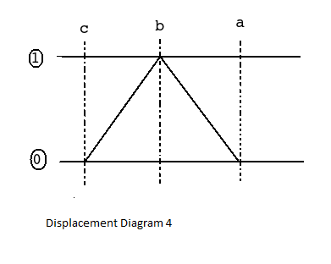
Correct answer: b.
Q 29. Overlapping of signals in pneumatic systems can be avoided by using
a) rolling lever valve | b) idle roller lever valve
c) both a and b | d) none of the above
Correct answer: c. both a and b
Q 30. What is the notation used for the sequence of operations mentioned below?
1. Cylinder A undergoes forward stroke
2. Cylinder B undergoes forward stroke
3. Cylinder A undergoes backward stroke
4. Cylinder B undergoes backward stroke
a) A– B– A⁺ B⁺ | b) A⁺ B– A⁺ B–
c) A⁺ B⁺ A– B– | d) A⁺ B– A⁺ B–
Correct answer: c. A⁺B⁺A–B–
Q 31. Which of the following statements is true for cascade method which is used to draw a pneumatic circuit?
a) signal processing valves are connected in parallel | b) when the number of signal processing valves are greater than 4, the signals are strong
c) cascade method does not consider the cost factor | d) all the above
Correct answer: c. cascade method does not consider the cost factor
Q 32. What is the part, shown in below diagram of 3/2 valve, called?
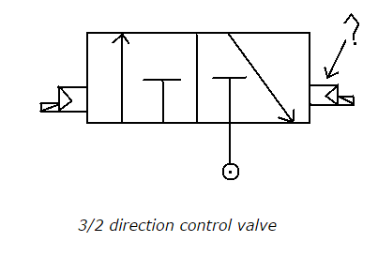
a) manually operated valve | b) pilot operated valve
c) pressure electric converter | d) none of the above
Correct answer: b. pilot operated valve
Q 33. How is proximity switch differentiated from limit switch?
a) proximity switch is activated when moving parts have physical contact with it | b) . proximity switch is activated when non-moving parts have physical contact
c) proximity switch is activated when moving parts are close to it | d) none of the above
Correct answer: c. proximity switch is activated when moving parts are close to it
Q 34. Which of the following statements is true?
a) electromagnetic relays have high reliability at more cost | b) electromagnetic relays use low current and voltage, to have open or close contact in high voltage and current circuit
c) air pressure passed to pressure electric converter opens a contact which energizes a circuit for the flow of electric contact | d) all the above
Correct answer: b. electromagnetic relays use low current and voltage, to have open or close contact in high voltage and current circuit
Q 35. In which circuits, relay of low voltage and low current is used to make open or close contact?
a) high voltage and high current circuit | b) low voltage and low current circuit
c) high voltage and low current circuit | d) low voltage and low current circuit
Correct answer: a. high voltage and high current circuit
Q 36. In electropneumatic circuits,
a) spool is shifted by signal air | b) spool is shifted by control air
c) spool is shifted by electromotive force | d) all the above
Correct answer: c. spool is shifted by electromotive force
Q 37. Why are electromechanical relays more popular than solid state relays?
a) they are reliable | b) less costly
c) both a and b | d) none of the above
Correct answer: c. both a and b
Q 38. What is the DC range of of solenoids in pneumatic systems?
a) 12 V and 24 V | b) 110 V and 220 V
c) both a and b | d) none of the above
Correct answer: a. 12 V and 24 V
Q 39. Which of the following statements are true?
a) piston pumps are self priming | b) piston pumps require high maintenance
c) piston pumps have low cost of production | d) piston pumps have low volumetric efficiency
Correct answer: 1 and 2
Q 40. ) __________ of PLCs can be done in very little time.
a) Programming | b) Installation
c) Commissioning | d) All of the above
Correct answer: All of the above
Q 41. The PLC is used in _______.
a) machine tools | b) automated assembly equipment
c) moulding and extrusion machines | d) all of the above
Correct answer: all of the above
Q 42. Which of the following can be the output of PLC?
a) Relay coils | b) Solenoids
c) Motors | d) Lamps
Correct answer: All the a, b, c, d
Q 43. Which of the following cannot be an input that is given to the PLC?
a) Manual switches | b) Relays
c) Sensors | d) None of the above
Correct answer: None of the above
Q 44. Which of the figures shown below represents the exclusive-NOR gate?
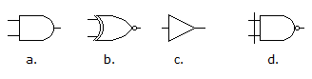
a) a | b) b
c) c | d) d
Correct answer: Option b

Q 45. Exclusive-OR (XOR) logic gates can be constructed from what other logic gates?
a) AND gates, OR gates, and NOT gates | b) OR gates only
c) AND gates and NOT gates | d) OR gates and NOT gates
Correct answer: AND gates, OR gates, and NOT gates
Q 46. The output of an AND gate with three inputs, A, B, and C, is HIGH when ________.
a) A = 1, B = 1, C = 0 | b) A = 0, B = 0, C = 0
c) A = 1, B = 1, C = 1 | d) A = 1, B = 0, C = 1
Correct answer: Option C
Q 47. (a+b+c)'=
a) a'b'c' | b) a'+b'+c'
c) abc | d) a+b+c
Correct answer: a a’b’c’
Q 48. PLC means ------------- logic controller
a) Programmable | b) Peripheral
c) Periodic | d) None of the above
Correct answer: Programmable
Q 49. A check valve is a/an:
- a) directional control valve | - b) counterbalance valve
- c) reducing valve | d) none of the above
- Correct answer: directional control valve
Q 50. Pilot-operated check valves have ___________flow in one direction.
- a) increased | - b) controlled
- c) decreased | d) none of the above
- Correct answer: controlled
Q 51. What is the name for information sent from robot sensors to robot controllers?
a) temperature | b) pressure
c) feedback | d) signal
Correct answer: feedback
Q 52. Which one of the following terms refers to the up - down motion of a robot arm?
a) yaw | b) pitch
c) roll | d) elevate
Correct answer: pitch
Q 53. Which of the following terms refers to the left – right movement of a robot arm?
a) yaw | b) vertical
c) pitch | d) swing
Correct answer: yaw
Q 54. Which of the following terms refer to the rotational motion of a robot arm?
a) swivel | b) axle
c) roll | d) yaw
Correct answer: roll
Q 55. What is the name for the space inside which a robot unit operates?
a) environment | b) work envelop
c) danger zone | d) exclusion zone
Correct answer: work envelop
Q 56. Which of the following terms IS NOT one of the five basic parts of a robot?
a) peripheral tools | b) end effector
c) controller | d) drive
Correct answer: peripheral tools
Q 57. The number of moveable joints in the base, the arm, and the end effector of the robot determines ............... ?
a) degrees of freedom | b) payload capacity
c) flexibility | d) operational limits
Correct answer: degrees of freedom
Q 58. For a robot unit to be considered a functional industrial robot, typically, how many degrees of freedom would the robot have?
a)three | b) four
c) six | d) eight
Correct answer: six
Q 59. Which of the following terms refers to the use of compressed gasses to drive (power) the robot device?
a) pneumatic | b) hydraulic
c) piezo electric | d) photo sensitive
Correct answer: pneumatic
Q 60. With regard to the physics of power systems used operate robots, which statement or statements is most correct?
a) hydraulics involves the compression of liquids | b) hydraulics involves the compression of air
c) pneumatics involve the compression of air | d) chemical batteries produce AC power
Correct answer: pneumatics involve the compression of air

