**WEBINAR**

**ON**

“ ***Making the Most out of your student experience at an academic institution:***

***Ideas and Reflections"***

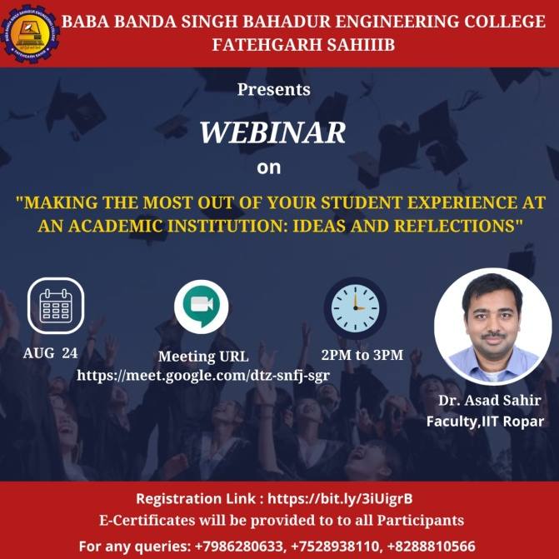

The Department of Management Studies of Baba Banda Singh Bahadur Engineering College. Fatehgarh Sahib organized a webinar on ***Making the Most out of your student experience at an academic institution: Ideas and Reflections”*** on 24th August 2020 through Google Meet. The distinguished speaker for the event was Dr Asad Sahir. He has been serving as the Head - Professional Development at IIT Ropar's Career Development and Corporate Relations Centre. He is an Assistant Professor at the Department of Chemical Engineering at IIT Ropar. His previous professional research experience includes his work at the US Department of Energy's National Renewable Energy Laboratory and Bharat Petroleum Corporation Limited's Corporate Research and Development Centre. He holds a PhD in Chemical Engineering from the University of Utah, Salt Lake City. In the webinar, he encouraged students to use their time in a productive manner in order to achieve the goal ser by them. He motivated the students to realize their full potential and the importance of self-worth. More than 80+ students have attended the webinar. The webinar was concluded with a vote of thanks from Principal Sir to the Dr Asad for sharing his valuable sights and experiences with the students.

**"WEBINAR ON MANAGEMENT OF TRAFFIC RULES**

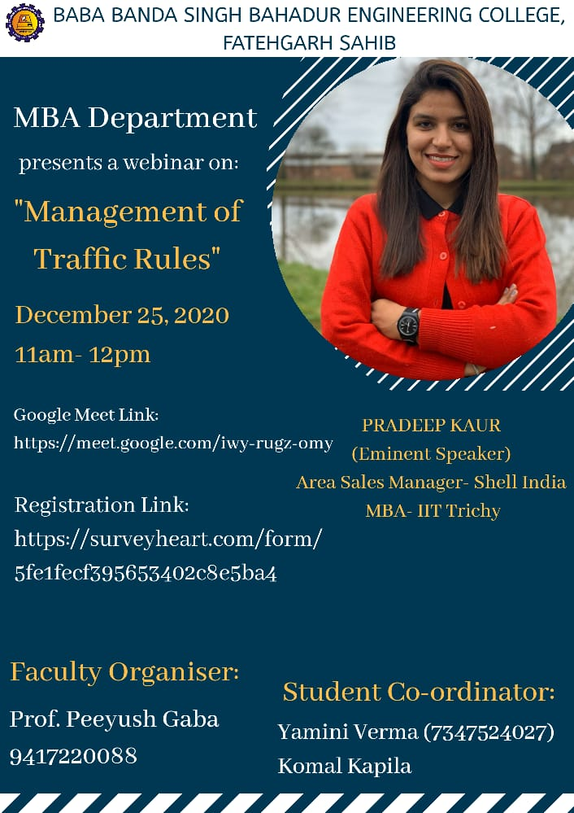

Webinar on "Management of Traffic Rules" was organized by Masters of Business Administration Department of Baba Banda Singh Bahadur Engineering College, Fatehgarh Sahib on 25th December, 2020. The webinar was conducted to create an awareness among the youth about the importance of traffic rules and traffic signs. The eminent speaker of this webinar was Pradeep Kaur. She is an Area Sales Manager in Mumbai- Shell India. There were around 50+ participants who registered the webinar and the webinar was conducted in the online mode on Google Meet platform. All the registered participants actively participated in the webinar and are awarded with "Certificate of Participation". The Principal Maj. Gen. Dr. G.S. Lamba congratulated all the participants for their enthusiastic particiption and appreciated Dr. Jasleen Kaur (HOB, MBA) along with all faculty members of MBA Department and the student co-ordinators Yamini Verma and Komal Kapila for the smooth conduct of the webinar.

**"WEBINAR ON ROLE OF SPIRITUALITY IN SELF -EXPLORATION"**

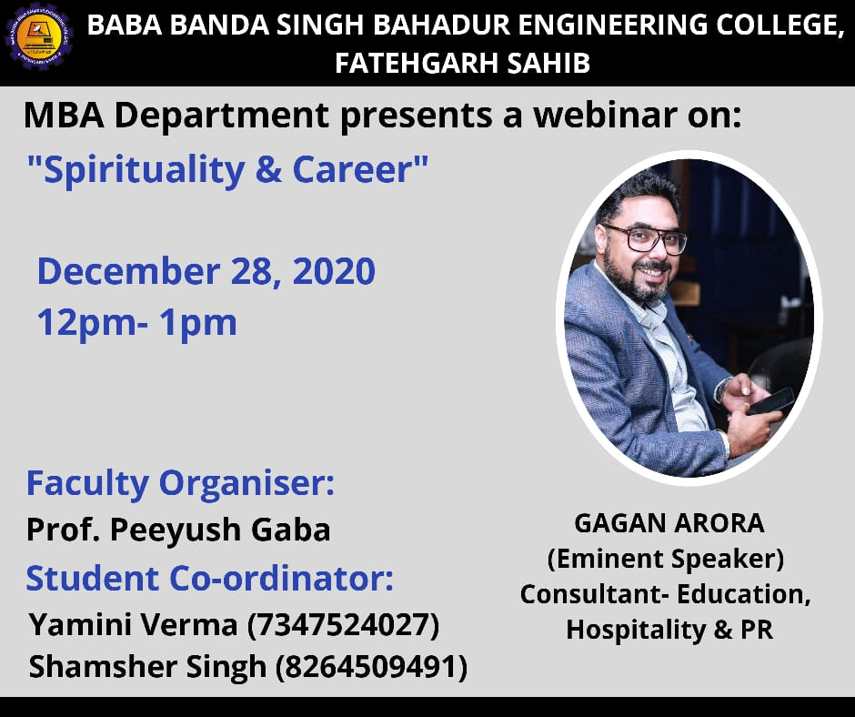

A Webinar on "Role of Spirituality in Self Exploration" was organized by Masters of Business Administration Department of Baba Banda Singh Bahadur Engineering College, Fatehgarh Sahib on 28th December, 2020. The webinar was conducted to know about the self exploration and aspirations of being happy and in prosperity. Gagan Arora was the eminent speaker of this webinar.  He is consultant in education, hospitality & PR and also the co- founder of CarNehlao Pvt. Ltd.  There were more than 50 participants who actively participated in the webinar and the webinar was conducted in the online mode on Google Meet platform. All the participants are awarded with "Certificate of Participation". The Principal Maj. Gen. Dr. G.S. Lamba congratulated all the participants for their enthusiastic particiption and appreciated Dr. Jasleen Kaur (HOB, MBA) along with all faculty members of MBA Department and the student co-ordinators Yamini Verma and Shamsher Singh for the smooth conduct of the webinar.

**State Level Debate Competition on Energy Conservation and Energy Efficiency**

To disseminate the knowledge of energy efficiency measures at the grass root level, PEDA with the support of Bureau of Energy Efficiency (BEE) had organized a State Level Debate Competition in association with MBA department on Energy Conservation and Energy Efficiency in [Baba Banda Singh Bahadur Engineering College](http://bbsbec.edu.in/) on 17th October 2018 in association with GMK Infra Solutions LLP.

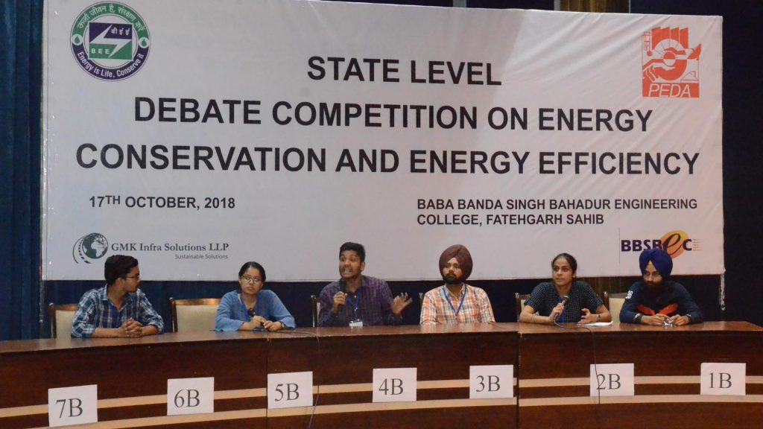

**Alumni Interaction**

The alumni of the MBA department interacted with the current students and shared their real industry experiences. They guided the students about the opportunities in the market and how to tap them strategically. They guided them regarding the career paths to be chosen in future as per the market demand.

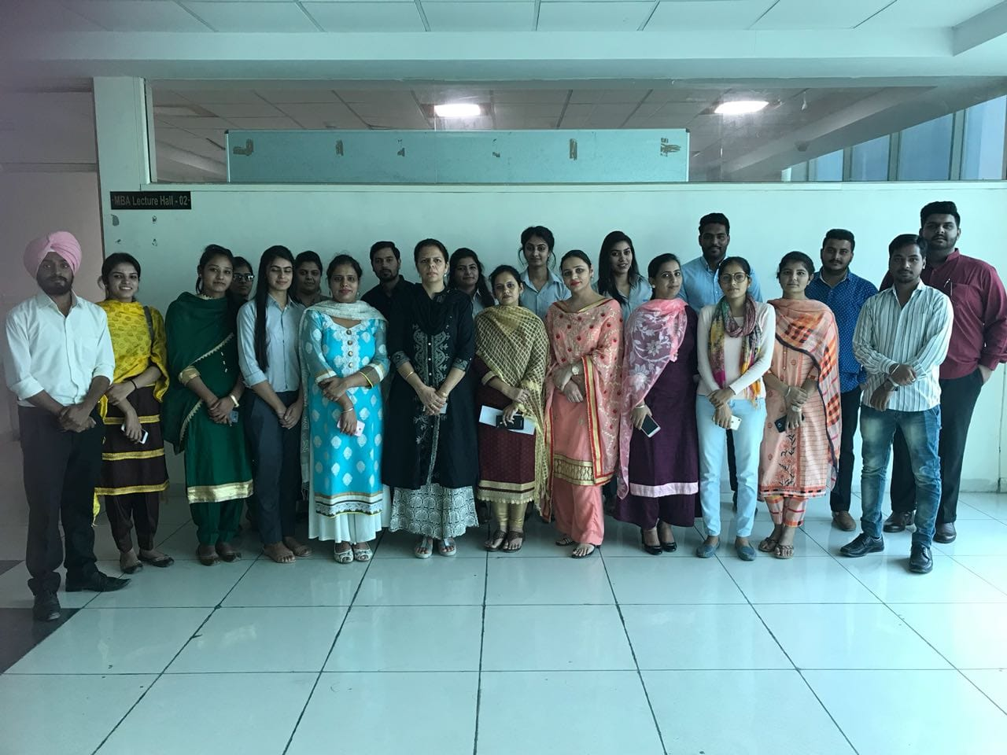

Gurpreet Singh

Gurpreet Singh, Student of Mba Final Year participated in Management Fest- “Gyan Manthan” organized at CGC Jhangeri and secured second position in the event “Best Manager” and was awarded with a trophy.

Hardeep Kaur

Hardeep Kaur , student of MBA Batch (2015-2017) got 2nd position in MBA at Maharaja Ranjit Singh University, Bathinda.