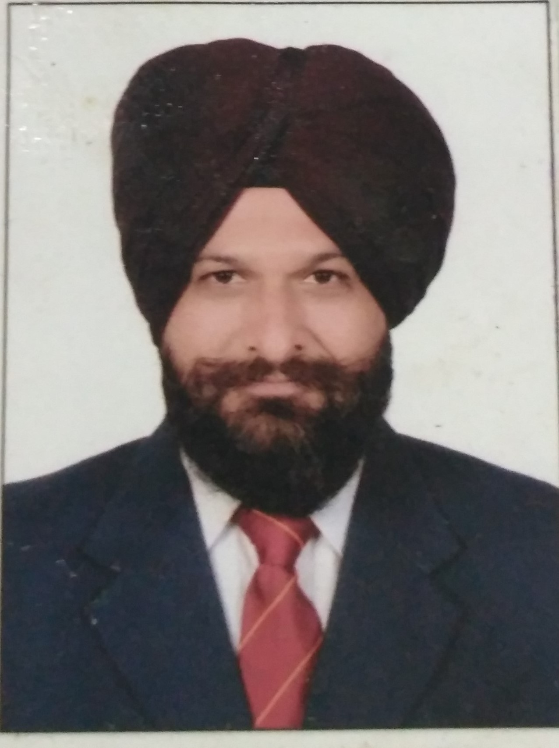
Raminder Singh Uppal
Flat No. 307, BBSBEC FGS
Punjab, Mob: +9198556-51466
Email: rsuppal@gmail.com

_______________________________________________________________________________

OBJECTIVE:
  - To Strive for academic excellence and impart quality education with emphasis on Electronics & Communication Engineering.
  - To inculcate the habit of executing effective implementation & rectification of electronics engineering problems in the minds of all concerned, which they can apply in their professional life in future.

ACADEMIC EXPERIENCE: 20 Years

Professor in the Department of Electronics and Communication Engineering, Baba Banda Singh Bahadur Engineering College, Fatehgarh Sahib since 1997 with experience of more than 20 years in the field of teaching and research.
- Lecturer/Assistant Professor: 19/10/2004
- Associate Professor: 19/10/2007

PROFESSIONAL QUALIFICATION:

FULL TIME COURSES:

- Phd Registered with Punjab Technical University (PTU) Jalandhar, Reg. No. 02.47.09 dated 19/08/2009.

- M. Tech. in Electronics and Communication Engineering form NIT Kurukshetra.

- B. Tech. in Electronics and Communication Engineering from GNDU campus Amritsar.

Area of Specialization:

Wireless Sensor Networks and Holistic Technologies.

Patent /Book: “System for Optimal Deployment of Emergency Vehicles” filed on 08/11/2016 with patent filing number 201611038046.

Administrative Experience:
- Test Coordinator of Building Vibration of Sensor Networks at BBSBEC Fategarh Sahib since 2012.
- Coordinator of CCTV security systems at SGPC Head Office, Shri Amritsar Sahib.
- Developing Soft Computing Algorithms for Ambulance Deployment in state of Punjab.
- Conducted 04 INSPIRE camps of DST New Delhi at BBSBEC.
- Member of BOG International Resource Centre of Punjab Technical University Jalandhar.
- Head of Department for more than 12 years,
- Head of ECE from March 2007 to 1 Jan 2012.
- Head of CSE from 1 Jan 2012 to Sep 2015.
- Head of ECE from 1 Sep 2015 to Till Date.

RESEARCH PUBLICATIONS:

- Uppal, R. S., Kumar, S., & Singh, H. (2013). Reliable and energy saving multipath routing in multi sink wireless sensor networks. GJCST-E: Network, Web & Security, 13(13).
- Uppal, R. S., Kumar, S., & Singh, H. (2014). A reliable and congestion control protocol for limited power wireless sensor networks. International Journal of Systems, Control and Communications, 6(2), 153-166.
- Uppal, R. S., & Kumar, S. (2016). Big Bang-Big Crunch Algorithm for Dynamic Deployment of Wireless Sensor Network. International Journal of Electrical and Computer Engineering (IJECE), 6(2), 596-601.
- Uppal, R. S., & Kumar, S. (2016). A BB-BC based Approach for Ambulance Deployment. Indian Journal of Science and Technology, 9(13).
- Singh, R., Singh, H., & Kaler, R. S. (2010, June). An adaptive energy saving and reliable routing protocol for limited power sensor networks. In Advances in Computer Engineering (ACE), 2010 International Conference on (pp. 79-85). IEEE.
- Uppal, R. S., & Kumar, S. (2016, March). Dynamic Deployment of Wireless Sensor Network using PBB-BC Algorithm. In Proceedings of the Second International Conference on Information and Communication Technology for Competitive Strategies (p. 43). ACM.

PATENT
- R. S. Uppal & Shakti Kumar, filed patent application on 08/11/206 titled “System for Optimal Deployment of Emergency Vehicles” with patent filing number 201611038046.
Personal Profile

D.O.B.: 20/12/1974
Gender: Male
Citizenship: Indian
Marital Status: Married
Present Address: Flat No. 307, BBSBEC FGS
Languages Known: English, Punjabi & Hindi

I hereby declare that above information is true and correct to the best of my knowledge and belief.

(RSUPPAL)

